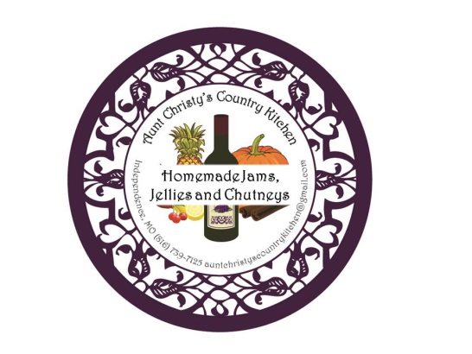
Aunt Christy’s Country Kitchen
http://www.auntchristyscountrykitchen.com
https://www.facebook.com/AuntChristysCountryKitchen
auntchristyscountrykitchen@gmail.com

JAM AND JELLY PRODUCT LIST
September 2016

FRUIT JAMS -
Blueberry Cinnamon Jam
Made with fresh blueberries and a touch of cinnamon, this jam will be a surprising treat for your tastebuds.
Cherry Vanilla Cardamom Jam
Made with fresh Michigan cherries, vanilla, and cardamom, this jam is smooth and spicy at the same time.
Chocolate Covered Cherry Jam
Combine tart Michigan cherries with dark cocoa powder and the result is a fruity jam with the rich taste of a chocolate covered cherry. Decadence!
New Jersey Traffic Jam (SEASONAL – June – Nov.)
If you have ever driven in rush hour traffic in New Jersey, you will see why this jam earns its unique name! Take raspberries, strawberries and blackberries, and add blueberries, the state fruit of New Jersey, and you have an amazingly fresh jam that tastes like the best that summer berries have to offer! It’s “jam-packed” with flavor!!!
Red Raspberry Jam (SEASONAL – June – Sept.)
Delightfully fruity, my raspberry jam is sweet and tart at the same time, with a phenomenally fresh raspberry taste!
Strawberry Balsamic Jam
Taste this delicious jam and you will never go back to store bought strawberry jam again! Combine fresh strawberries with a hint of balsamic vinegar and the result is a tangy, yet sweet explosion of flavor!

FRUIT CHUTNEYS -
Cranberry Apple Chutney (SEASONAL – Oct. – Jan.)
Blended with sweet apples, tart cranberries and warm autumn spices, this delightful chutney will certainly create a party in your mouth!

COCKTAIL JAMS AND JELLIES -
Southern Peach Smash (SEASONAL – June – Oct.)
Just the right blend of fresh peaches, cinnamon, vanilla beans and bourbon makes this jam a perfect addition to a cold dish of vanilla ice cream, or a hot buttery biscuit!

