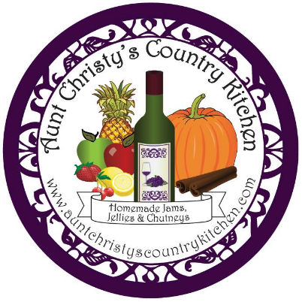
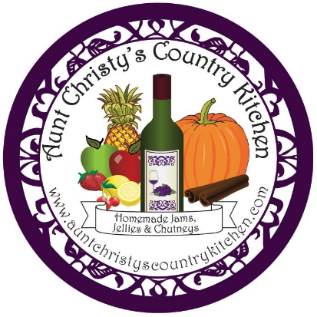
Aunt Christy’s Country Kitchen
http://www.auntchristyscountrykitchen.com
https://www.facebook.com/AuntChristysCountryKitchen
auntchristyscountrykitchen@gmail.com

JAM AND JELLY PRODUCT LIST
October 2017

FRUIT JAMS - $7.00/4 oz
Blueberry Cinnamon Jam
Made with fresh blueberries and a touch of cinnamon, this jam will be a surprising treat for your tastebuds.
Cherry Vanilla Cardamom Jam
Made with fresh Michigan cherries, vanilla, and cardamom, this jam is smooth and spicy at the same time.
Chocolate Covered Cherry Jam
Combine tart Michigan cherries with dark cocoa powder and the result is a fruity jam with the rich taste of a chocolate covered cherry. Decadence!
Gingerly Pear Jam (SEASONAL – Oct. - Dec.)
Fresh ginger, sweet pears, and tangy lime gives this jam a light and refreshing flavor with a tiny bit of heat.
Grandma’s Apple Pie Jam (SEASONAL – Oct. - Dec.)
A jam that tastes just like Grandma's homemade apple pie? Oh yes! Warm autumn spices, caramelized brown sugar, and tart granny smith apples will have your mouth watering for a taste of my newest seasonal jam, Grandma's Apple Pie Jam!
New Jersey Traffic Jam (SEASONAL – June – Nov.)
If you have ever driven in rush hour traffic in New Jersey, you will see why this jam earns its unique name! Take raspberries, strawberries and blackberries, and add blueberries, the state fruit of New Jersey, and you have an amazingly fresh jam that tastes like the best that summer berries have to offer! It’s “jam-packed” with flavor!!!
Red Raspberry Jam (SEASONAL – June – Sept.)
Delightfully fruity, my raspberry jam is sweet and tart at the same time, with a phenomenally fresh raspberry taste!
Strawberry Balsamic Jam
Taste this delicious concoction and you will never go back to store bought strawberry jam again! Combine fresh strawberries with a hint of balsamic vinegar and the result is a tangy, yet sweet explosion of flavor!

FRUIT CHUTNEYS - $7.00/4 oz
Cranberry Apple Chutney (SEASONAL – Oct. – Jan.)
Blended with sweet apples, tart cranberries and warm autumn spices, this delightful chutney will certainly create a party in your mouth!

COCKTAIL JAMS AND JELLIES - $7.00/4 oz
Southern Peach Smash (SEASONAL – June – Oct.)
Just the right blend of fresh peaches, cinnamon, vanilla beans and bourbon makes this jam a perfect addition to a cold dish of vanilla ice cream, or a hot buttery biscuit!

Fire In The Belly Jelly (SEASONAL – Oct. - Dec.)
Cinnamon whiskey, apple cider, and a blend of sweet and savory spices gives this jelly a sweet and warm flavor that pumps up your palette and satisfies your belly!!

WINE JELLIES - $8.00/4 oz
Blackberry Merlot Wine Jelly
Made from a medium-bodied merlot with undertones of black pepper and berries and infused with fresh blackberries, this velvety jelly is great for just about anything. Mix it with cream cheese for a great spread for bagels, or pair it with some peanut butter to make the best gourmet PB&J sandwich ever!
Cabernet Sauvignon Wine Jelly
Made from a smooth cabernet, with rich cherry/plum/spice undertones, this jelly will certainly be the best grape jelly you have ever tasted! Use it on the usual choices (bread, biscuits, croissants) or kick it up a notch and try it warm over chocolate ice cream. I guarantee you will be back for more!
Raspberry Hibiscus Chardonnay Wine Jelly
With its warm, buttery undertones and fruity taste, this jelly will leave a wonderful impression on your palate. Serve it warm over ice cream, with cream cheese and crackers at a party, or as a dipping sauce for chicken. Perfectly yummy!
Vanilla Bean Moscato Wine Jelly
VANILLA BEAN MOSCATO WINE JELLY is made from sweet moscato wine and vanilla beans. This jelly is so creamy and delicious, you will want to keep eating it. The vanilla enhances the sweetness of the moscato, blending with it perfectly to create a smooth jelly that is perfect over cream cheese, or vanilla ice cream.

